

**Faculty of Contemporary Sciences and Technologies**

**Tetovo**

**Database**

**(Sem. 4, 2022/23)**

**Project: “*The database application for a car dealership”***

**Student(s)**: **Mentor**:

1. First student (129205, Agon Muharemi) Prof. dr. Jaumin Ajdari

# Abstract

A database application where will be stored the data and organization of a car dealership, the database of the car dealership will enhance the car sales in the company and better manage the company were all the data of the sellers and the clients will be stored, the clients will have a contract for every car that they are interested from the dealership etc.

To solve the above problem, we plan to use Microsoft SQLServer for DBMS (into which will be implemented the database) and Microsoft Access as a tool for interface implementation.

**Key words:** Car dealership, Database, Application, DBMS, SQLServer, MS Access.

Contents

Abstract 2

1.1.Problem description 4

1.2.Business rules 4

1.3 Conceptual design 5

2.Realational design 13

1. Entity types, mapping of the entity types 13

2. Relationships, Mapping of the relationships 14

3. The whole solution 16

4. Schema normalization 17

5. SQL Code and implementation 18

5.1 Database diagram 20

5.2 Data insertion 21

Location 21

Salesman 21

Car 21

Client 22

CostumerVisit 22

Deal 22

6. The Interface 23

6.1 Connection to MS SQLServer 23

6.2 Insert forms 23

6.3 Tables with data 26

6.4 Examples 28

Query 1. 28

Query 2. 28

Query 3. 29

# 1.1.Problem description

A car dealership is interested in automatizing its selling and contracting activity. The Company contains the car displaying area, salespersons, and the cars.

The organization activity: A client comes to the dealership to look for a vehicle, were the salesperson will help him/her with their specifications for the car, if they are interested they will make a contract with the car dealership, were the data of all the activity of the clients visits and contracts will be recorded.

The car dealership owner is interested in modernising and automatizing the company for better performance of the dealership. The owner specified that he would open another car dealership in a different location, were he can use the same database without any data synchronization with the dealership he has already.

The data that were collected are from the clients, were they collected their name, surname, phone number, country etc.

Each salesman will register the data of the clients, were there would be client visits so the owner would evaluate his business.

Also, the company wats to store the data of clients in unique codes where they would have their history and contracts.

Company is interested in a database application

# 1.2.Business rules

We should design a database to collect and store data about clients, cars, salesman, contract, locations (the dealership location).

The database should fulfil the requirements:

1. In the car industry, there is a difference between the sale date and the delivery date of the car. The sales date is the date when the clients agrees to purchase a car and places a down payment. The delivery date is the date when the car in taken home by the owner. These are sometimes the same but not always.
2. One salesman can get credit for the selling of a car.
3. Salesman will be permitted to view all customer records and add new costumers.
4. The manager will be permitted to add or delete salesman in the database.
5. Salesman will be obligated to register all costumers that come to the dealership and register them at the database.

# 1.3 Conceptual design

We should find the entity types and possible attributes and draw the entity-relationship diagram (E-R diagram) for given problem. The problem will be solved according to the rule based on four steps which are given on our exercises.

**Step 1:** We try to find entity types and for each entity type all the possible attributes. By reading the text we find the entity types: Location (LocID, Locname), Client (Cid, Cname, Csurname, Caddres, Ccountry, Cphone, Cemail), Clientvisits (CVID, Visitdate, Testdrive, Visitdetail), Salesman (SID, Sname, Ssurname, Stype), Car (CarID, Carmark, Carmodel, Caryear, New or Old, Cprice, Cardetail), Deal (DealID, Saleprice, Deliverydate).

1.Location

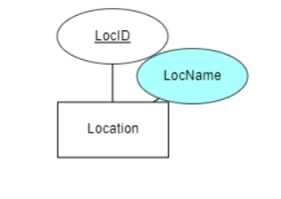

2.Client

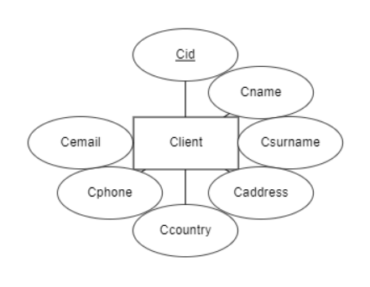

3.Clientvisits

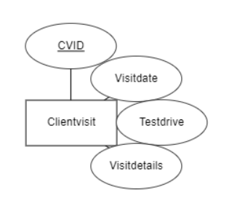

1. Salesman

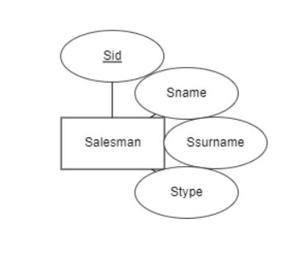

1. Car

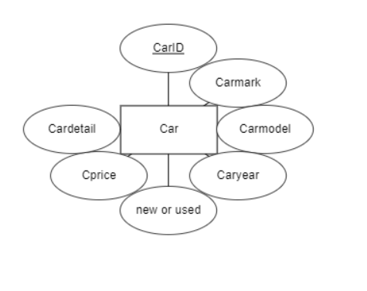

1. Deal

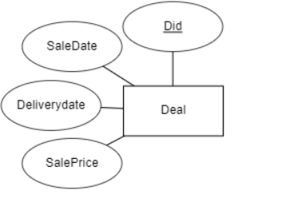

**Step 2:** Now, we start from Location, which it will have relations with salesman and car because they are located there were we will have the inventory of the cars and the salesman that are selling the car, then we have the salesman who has relationships with clientvisits and deals, car has a relation with the deal were all the data will be taken from the car from the unique id, Clients will need to have a relation with the deal so there data as a participant of the deal for the car will take place and clients will have a relation with the client visits for what they were interested in cars etc.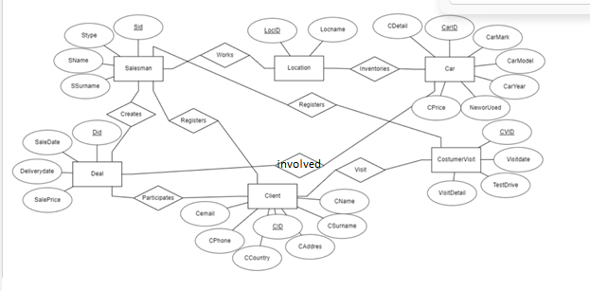

**Step 3:** Based on the step 2 and the requests we can define relationships

* The relation between Location and salesman is 1 with many were we have one salesman who can work in one location, but the salesman cannot work in many locations at the same time, and the relation’s name is has, were the location is mandatory to have salesman and salesman are mandatory in a location.

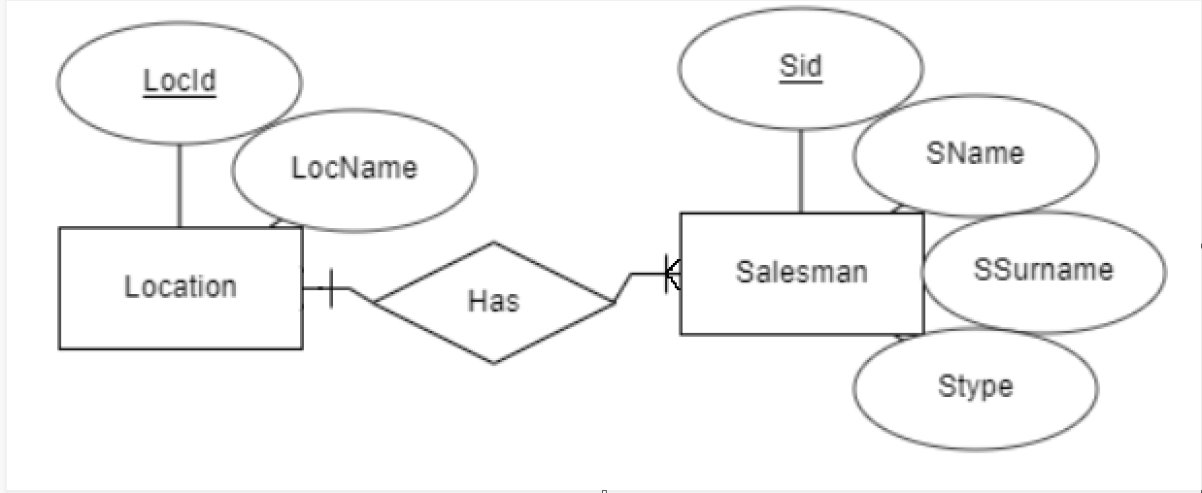

* The relation between Location and cars is 1 with many, the logic behind this is that the location can have many cars and the cars only can be in one location, and the name of the relation is inventories or displays, where location is mandatory to have cars and cars are mandatory to be in a location.

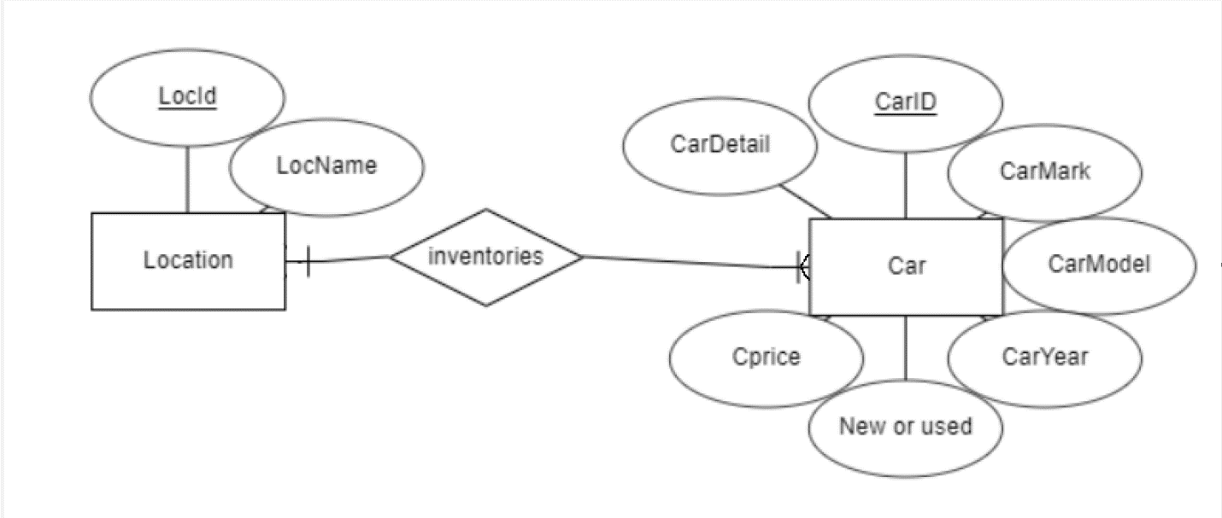

* The relation between Clients and Clientvisits the connection is 1 with many where the clients might have a lot of visits, the visits are made by one client, where the relation is named visits, the entity customervisits is mandatory to have clients but a client is not mandatory to participate in costumervisits.

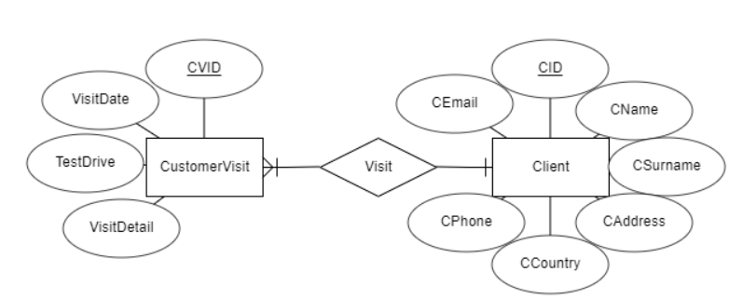

* The relation between salesman and customervisits is a relation 1 with many where a salesman can register a lot of costumer that visit the dealer and were the costumervists can be registered by one salesman the entity customervisits is mandatory to be registerd but a salesman is not mandatory to be register costumervisits (it depends on the customer if he allows it)

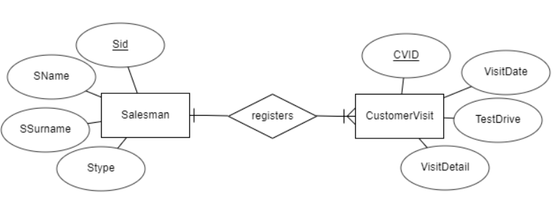

* The relation between deal and client is a relation 1 with one were the deal has one client and the client can have one deals were the participation is mandatory for the deal in this case.

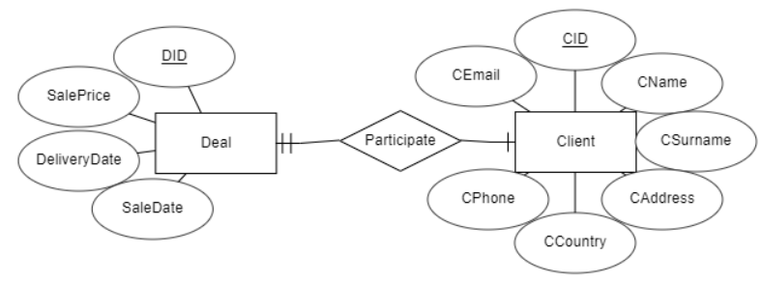

* The relation between the salesman and deal is 1 with many were the salesman can have many deals, and deals can have one salesman were the salesman is mandatory to have participation in the deal, the deal is not mandatory to have salesman(if the salesman hasn’t made any sales example).

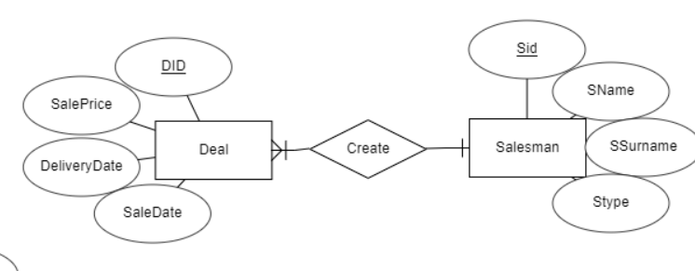

* The relation between deal and car is 1 with 1 where the deal can have one car, only one car is specified in a deal, were the participation is mandatory for the car.

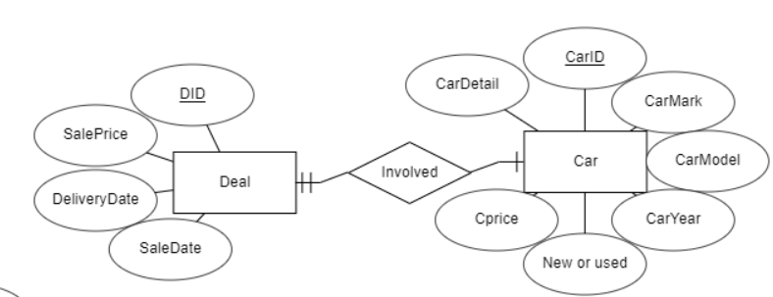

So, when we combine them all together, we get the E-R diagram of the database.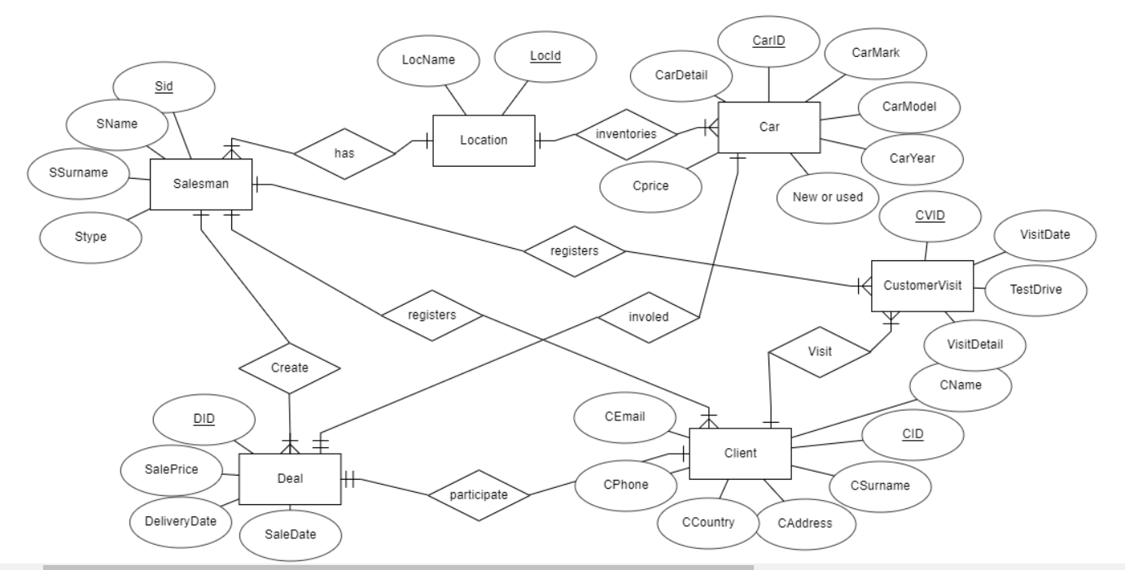

Solution by use of Oracle SQL Developer

1. Conceptual modeling ( E-R diagram, Logic Design )

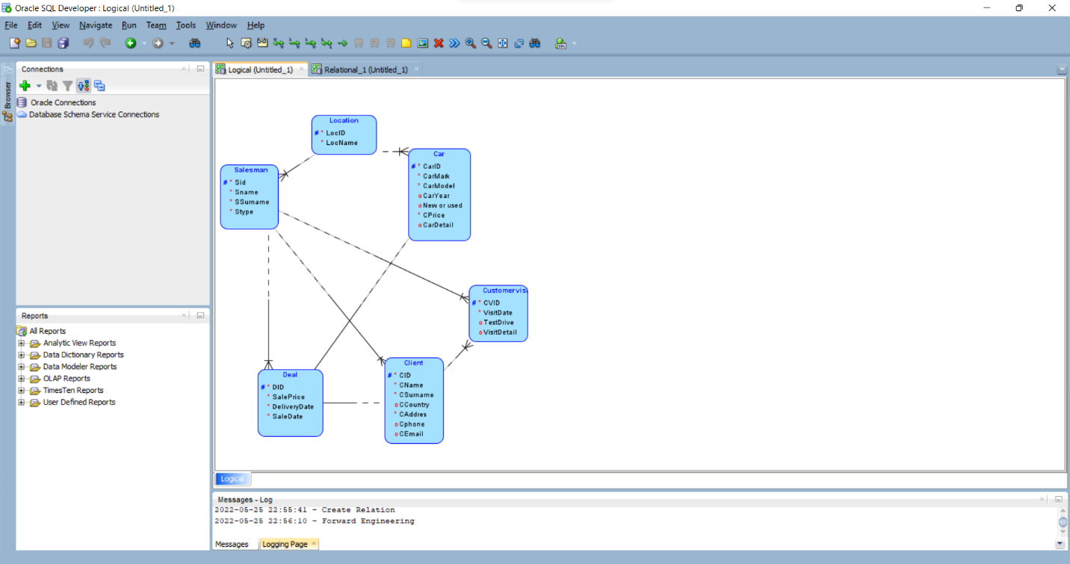

1. Relational Model

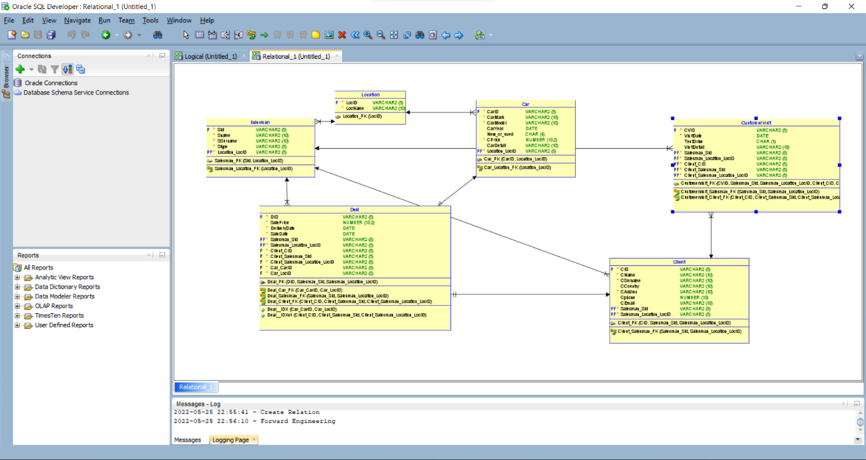

# 2.Realational design

The E-R diagram for the given problem

With use of the relational mapping rules we convert the E-R diagram to relational model (relational diagram). We solve step by step the conceptual elements within E – R diagram.

## 1. Entity types, mapping of the entity types

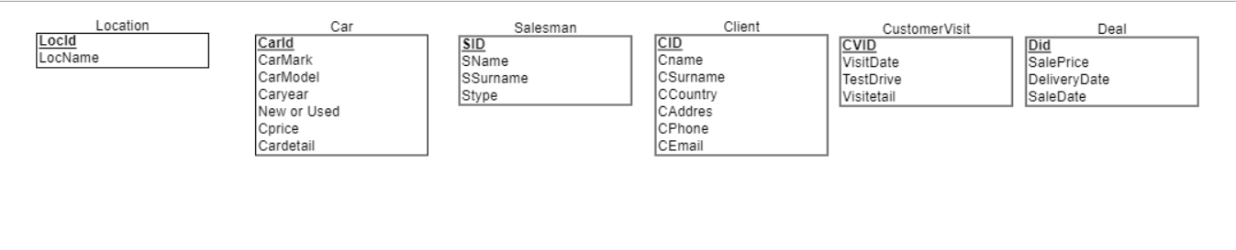

## Relationships, Mapping of the relationships

* 1:N between Location and Salesman, Salesman has total participation. According to the rules of mapping od the realtionship with the key contraint, the relation Salesman will be changed.

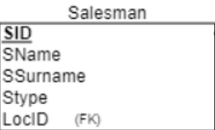

* 1:N between Location and Car, Car has total participation. According to the rules of mapping od the realtionship with the key contraint, the relation Car will be changed.

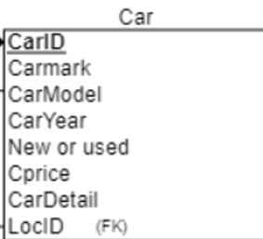

* 1:N between Client and Salesman, Client has total participation. According to the rules of mapping od the realtionship with the key contraint, the relation Client will be changed.

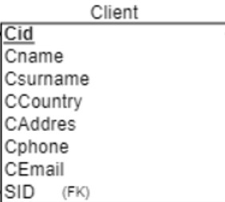

* 1:N between CustomerVisit and Salesman, CustomerVisit has total participation. According to the rules of mapping od the realtionship with the key contraint, the relation CustomerVisit will be changed. 1:N between CustomerVisit and Client, CustomerVisit has total participation. According to the rules of mapping od the realtionship with the key contraint, the relation CustomerVisit will be changed again.

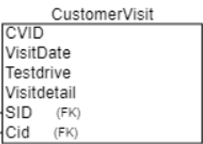

* 1:N between Deal and Salesman, Deal has total participation. According to the rules of mapping od the realtionship with the key contraint, the relation Deal will be changed.

1:1 between Deal and Car, Deal has total participation. According to the rules of mapping od the realtionship with the key contraint, the relation Deal will be changed again.

1:N between Deal and Client, Deal has total participation. According to the rules of mapping od the realtionship with the key contraint, the relation Deal will be changed.

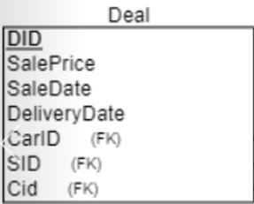

## The whole solution

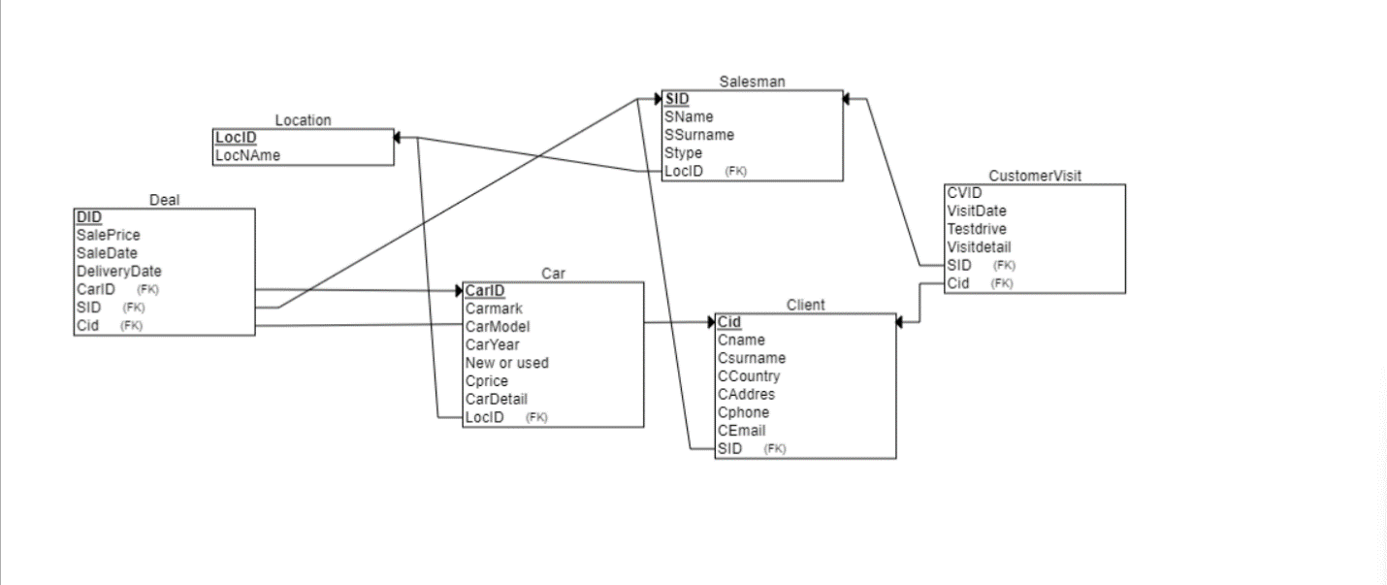

# Schema normalization

According to the above relation diagram the relations are:

Location ( LocID, LocName ),

Salesman ( SID, LocID , SName, SSurname, SType )

Car ( CarID, LocID, CarMark, CarModel, CarYear, New or Used, Cprice, CarPrice )

Client ( CID, SID, CName, CSurname, CCountry, CAddres, CPhone, CEmail )

CustomerVisit ( CVID, CID, SID, VisitDate, TestDrive, VisitDetail)

Deal ( DID, CarID, SID, CID, SalePrice, SaleDate, DeliveryDate)

The first five relations contain primary keys were from all of them there is one entity that doesn’t need a foreign key from the other entities and it is the main part of the project and that is the Location, why it is the important part because it is the place where the cars and the salesman are located and it starts from there. The other entities are with their foreign keys for example Salesman will have the LocID were it will identify in which location he works; it is the same case in the entity Cars witch shows where they are located.

The other entities Client will have the foreign key from Salesman that will identify witch salesman did the consultation with the customer, we have another case where we have CustomerVisit were it has both the CID and SID.

The Deal is the final part where it will make a contract with all the data of the Client, Salesman and CarID where these foreign keys are needed for completing the contract.

Through the rational diagram the design is made with the database schema Boyce-Codd normal (BCNF) form.

# SQL Code and implementation

SQL, Database creation and table creation, the tables creation order is

determined by the arrows which are used into step 3 (part 3), therefore, firstly, we

create the tables which are not referenced from any other table and always the table

which references to any other table will be created after the table to which refers (after

table to which points).

--CREATING DATABASE

USE MASTER

GO

--now we are able to delete database, if exists

if (DB_ID('CAR_DEALERSHIP') is not null)

drop database CAR_DEALERSHIP

go

--RECREATING DATABASE

CREATE DATABASE CAR_DEALERSHIP

GO

--USE OF DATABASE

USE CAR_DEALERSHIP

GO

--TABLE CREATION

CREATE TABLE location (

locid VARCHAR(5) NOT NULL,

locname VARCHAR(10) NOT NULL,

--DEFINING THE PRIMARY KEYS

PRIMARY KEY (locid)

);

--TABLE CREATION

CREATE TABLE salesman (

sid VARCHAR(5) NOT NULL,

sname VARCHAR(10) NOT NULL,

ssurname VARCHAR(10) NOT NULL,

stype VARCHAR(5) NOT NULL,

salesman_locid VARCHAR(5),

--DEFINING THE PRIMARY KEYS

PRIMARY KEY(sid),

--DEFINING THE FOREIGN KEYS

FOREIGN KEY (salesman_locid) REFERENCES location(locid)

);

--TABLE CREATION

CREATE TABLE car (

carid VARCHAR(5) NOT NULL,

carmark VARCHAR(10) NOT NULL,

carmodel VARCHAR(10) NOT NULL,

caryear DATE,

new_or_used CHAR(4),

cprice NUMERIC(10, 2) NOT NULL,

cardetail VARCHAR(10),

car_locid VARCHAR(5) ,

--DEFINING THE PRIMARY KEYS

PRIMARY KEY(carid),

--DEFINING THE FOREIGN KEYS

FOREIGN KEY (car_locid) REFERENCES location(locid)

);

CREATE TABLE client (

cid VARCHAR(5) NOT NULL,

cname VARCHAR(10) NOT NULL,

csurname VARCHAR(10) NOT NULL,

ccountry VARCHAR(10),

caddres VARCHAR(10) NOT NULL,

cphone NUMERIC(10),

cemail VARCHAR(15),

salesman_id VARCHAR(5) ,

--DEFINING THE PRIMARY KEYS

PRIMARY KEY(cid),

--DEFINING THE FOREIGN KEYS

FOREIGN KEY (salesman_id) REFERENCES salesman(sid)

);

--TABLE CREATION

CREATE TABLE customervisit (

cvid VARCHAR(5) NOT NULL,

visitdate DATE NOT NULL,

testdrive CHAR(1),

visitdetail VARCHAR(10),

salesman_id VARCHAR(5),

client_id VARCHAR(5),

--DEFINING THE PRIMARY KEYS

PRIMARY KEY(cvid),

--DEFINING THE FOREIGN KEYS

FOREIGN KEY (salesman_id) REFERENCES salesman(sid),

FOREIGN KEY (client_id) REFERENCES client(cid)

);

CREATE TABLE deal (

did VARCHAR(5) NOT NULL,

saleprice NUMERIC(10, 2) NOT NULL,

deliverydate DATE NOT NULL,

saledate DATE NOT NULL,

salesman_id VARCHAR(5),

client_id VARCHAR(5),

car_id VARCHAR(5),

--DEFINING THE PRIMARY KEYS

PRIMARY KEY(did,salesman_id,client_id,car_id),

--DEFINING THE FOREIGN KEYS

FOREIGN KEY (salesman_id) REFERENCES salesman(sid),

FOREIGN KEY (client_id) REFERENCES client(cid),

FOREIGN KEY (car_id) REFERENCES car(carid)

);

# Database diagram

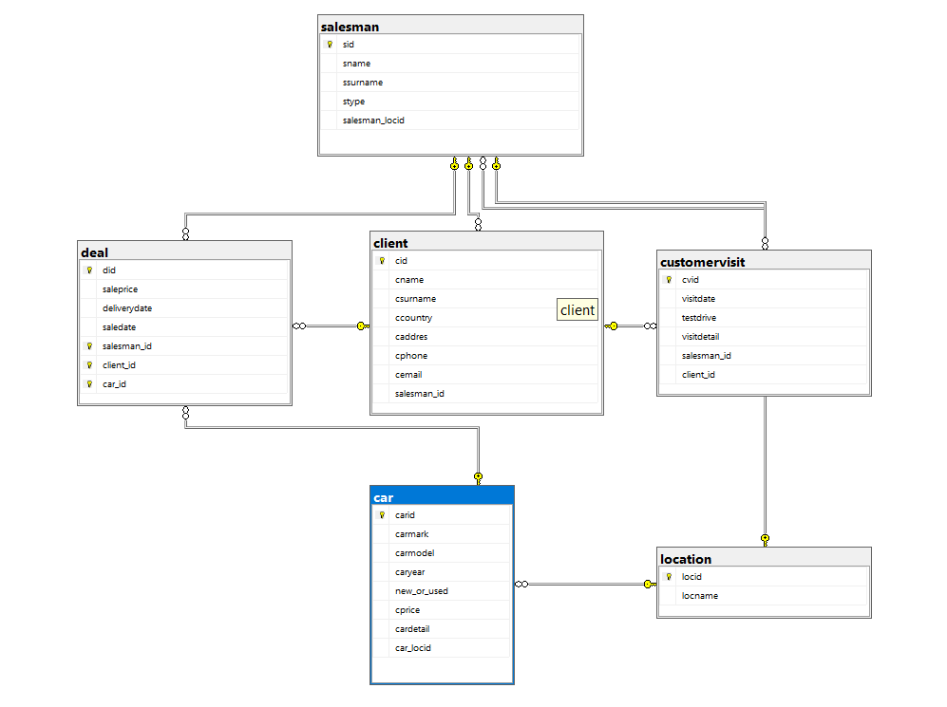

# Data insertion

Fill the tables with data,

## Location

INSERT INTO location(locid,locname)

VALUES

(00001,'dealership'),

(00002,'dealership')

## Salesman

INSERT INTO salesman(sid,sname,ssurname,stype,salesman_locid)

VALUES

(00001,'albin','alili','man',00001),

(00002,'agon','muh','sal',00001),

(00003,'rinor','dal','sal',00001),

(00004,'sem','alli','sal',00001),

(00005,'muhamed','ali','man',00002),

(00006,'albin','amiti','sal',00002),

(00007,'muh','alili','sal',00002),

(00008,'loki','sela','sal',00002)

## Car

INSERT INTO car(carid,carmark,carmodel,caryear,new_or_used,cprice,cardetail,car_locid)

VALUES

(00001,'AUDI','A4','12/12/2022','NEW',100000,'fulloption',00001),

(00002,'AUDI','A7','12/12/2022','NEW',190000,'fulloption',00001),

(00003,'AUDI','RS6','12/12/2022','NEW',180000,'fulloption',00001),

(00004,'AUDI','R8','12/04/2022','NEW',200000,'fulloption',00001),

(00005,'BMW','M3','01/01/2022','NEW',120000,'medoption',00001),

(00006,'BMW','M3','03/04/2015','USED',56000,'fulloption',00001),

(00007,'BMW','M4-COM','12/01/2022','NEW',140000,'fulloption',00002),

(00008,'TOYOTA','SUPRA','12/11/2022','NEW',99000,'fulloption',00002),

(00009,'HONDA','CIVIC','05/12/2022','NEW',660000,'fulloption',00002),

(00010,'HONDA','S2000','01/01/2022','NEW',78000,'fulloption',00002),

(00011,'SUBRAU','WRX','12/12/2012','USED',86000,'fulloption',00002),

(00012,'AUDI','A4','12/12/2008','USED',150000,'lowoption',00002)

## Client

INSERT INTO client(cid,cname,csurname,ccountry,caddres,cphone,cemail,salesman_id)

VALUES

(00001,'arben','muh',NULL,'ZONA 6',072465484,NULL,00001),

(00002,'ali','mehmedi','S.ARABIA','ELMEDIN 36',75648452,NULL,00001),

(00003,'jeton','rasimi',NULL,'MAHMUDOVCI ',NULL,'J.RASIMI@GMAIL',00004),

(00004,'viktor','unikatil','kosov','adresa2',0968451485,NULL,00003),

(00005,'arben','besa',NULL,'ADRESA 6',072465484,NULL,00008),

(00006,'AGON','KRALI',NULL,'ADRESA 10',14513215,NULL,00005)

## CostumerVisit

INSERT INTO customervisit(cvid,visitdate,testdrive,salesman_id,client_id)

VALUES

(00001,'05/12/2022','Y',00002,00001),

(00002,'05/11/2022','N',00004,00002),

(00003,'08/10/2022','Y',00006,00003),

(00004,'05/12/2022','N',00008,00004),

(00005,'05/09/2022','N',00002,00005),

(00006,'06/12/2022','Y',00005,00006)

## Deal

INSERT INTO deal(did,saleprice,deliverydate,saledate,salesman_id,client_id,car_id)

VALUES

(00001,122000,'02/03/2022','02/03/2022',00002,00004,00003),

(00002,110000,'02/03/2022','02/02/2022',00003,00004,00005),

(00003,46000,'04/05/2022','03/05/2022',00002,00003,00006),

(00004,99000,'05/12/2022','02/03/2022',00005,00001,00001)

# The Interface

## 6.1 Connection to MS SQLServer

Database is stored into MS SQLServer and the use of the database is

implemented from MS Access. The connection from Access to SQLServer is

implemented by use of ODBC connection.

## 6.2 Insert forms

To insert data into our database we use the forms:

To insert a row into table Location is created the form

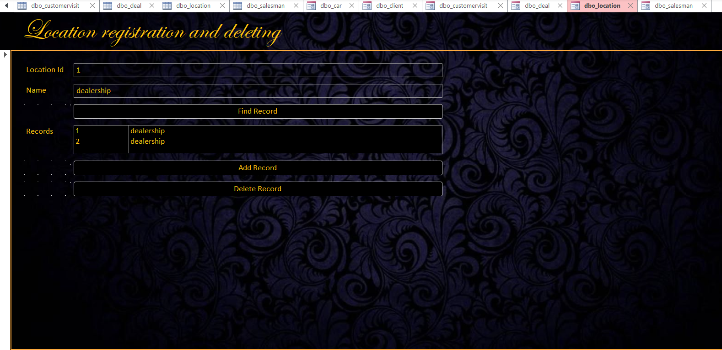

For insert to Salesman, we use the form

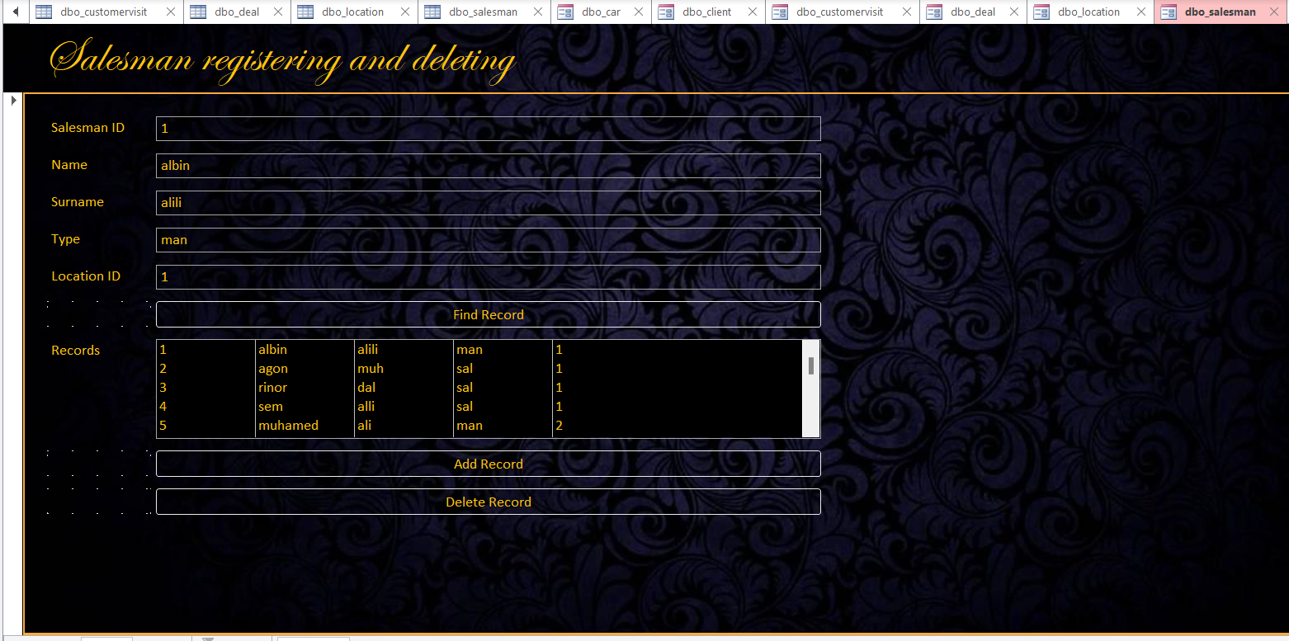

For insert to Cars, we use the form

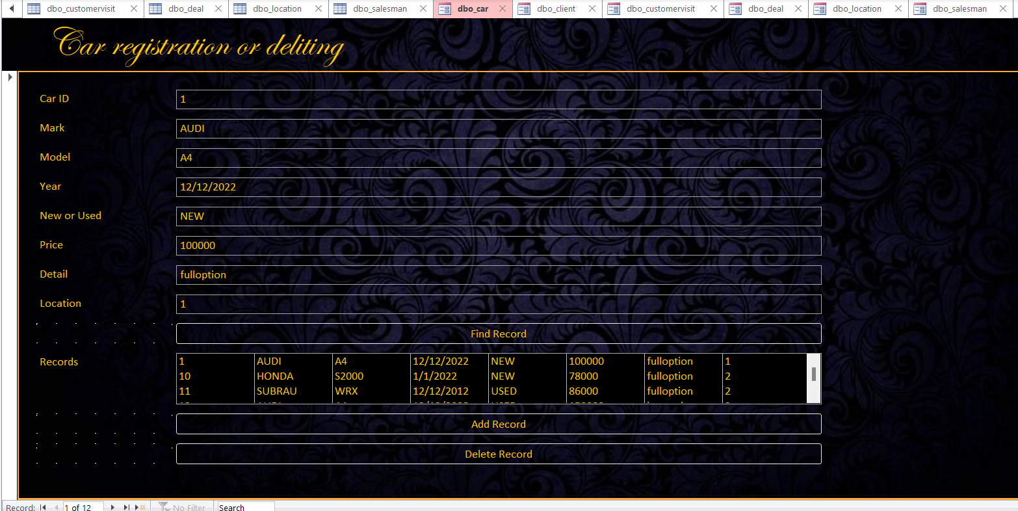

For insert to Client, we use the form

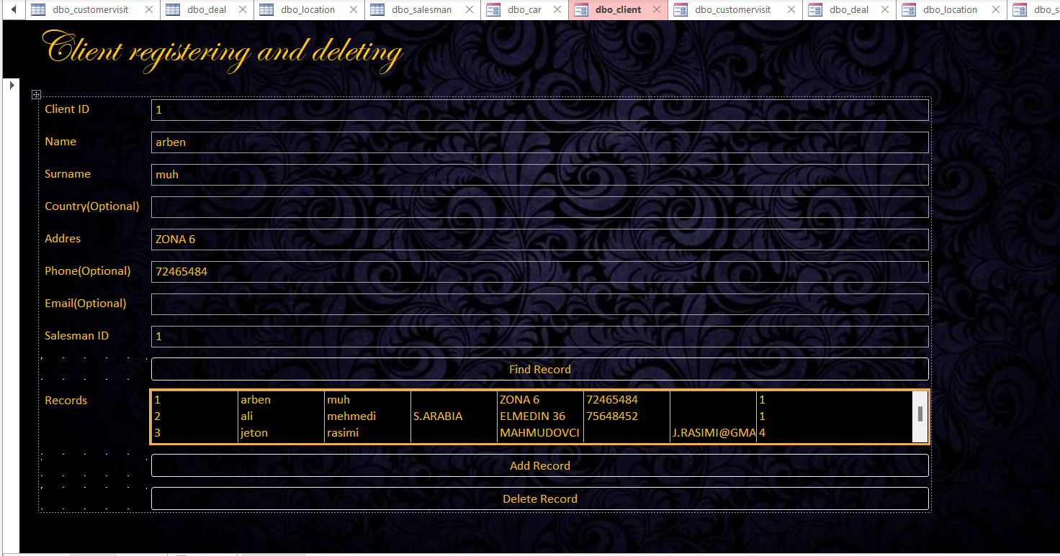

For insert to Customer Visit, we use the form

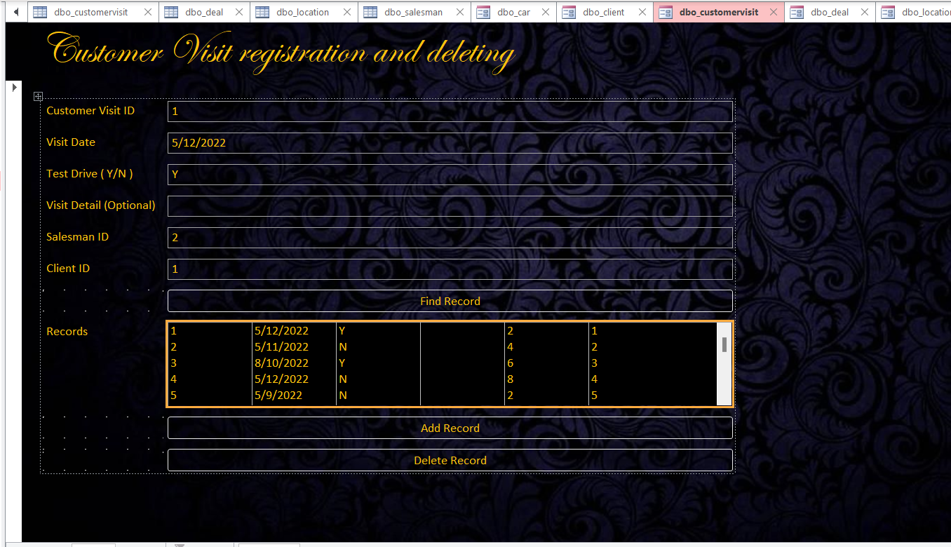

For insert to Deal, we use the form

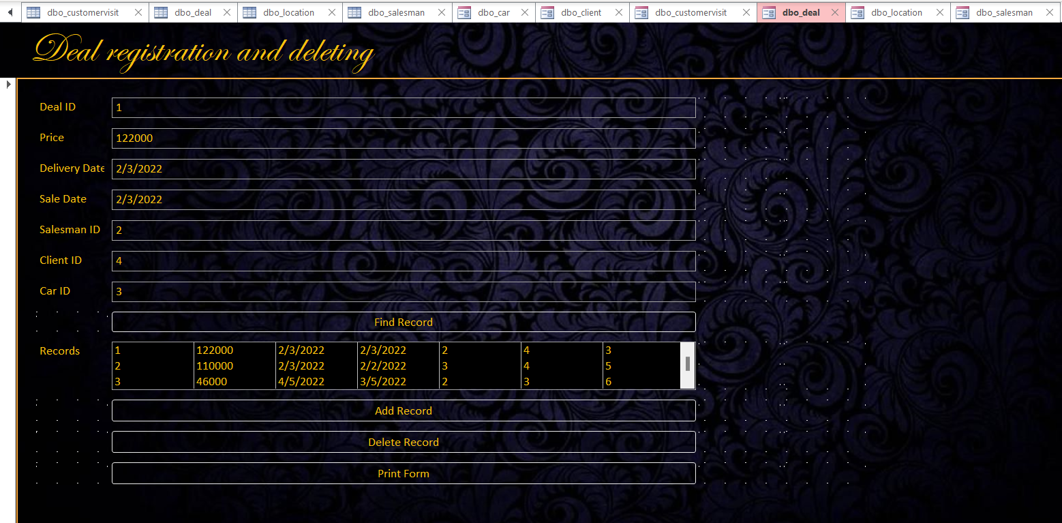

## 6.3 Tables with data

Table Location

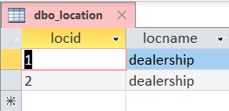

Table Car

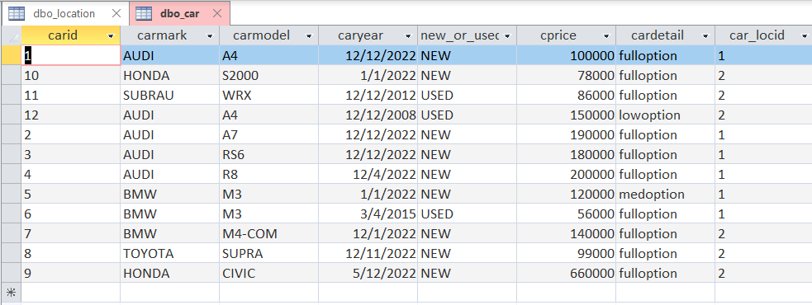

Table Salesman

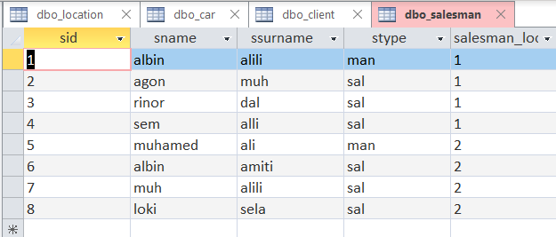

Table Client

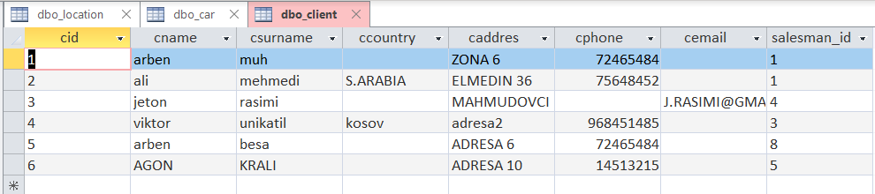

Table Customer Visit

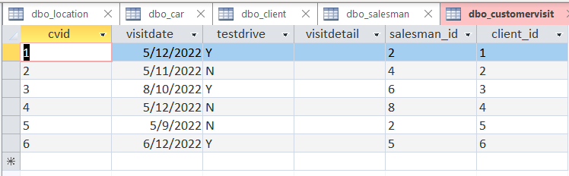

Table Deal

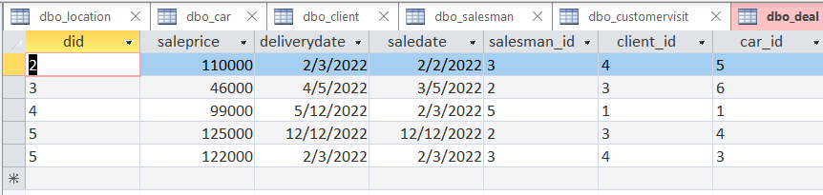

## 6.4 Examples

Query 1. Find all the cars with the mark AUDI.

SQL

SELECT * FROM car WHERE carmark = 'AUDI'

Results

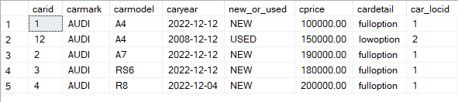

Query 2. Find all the clients with the name ARBEN.

SQL

SELECT * FROM client WHERE cname = 'ARBEN'

Results

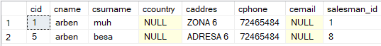

Query 3. Find all the deals with clientid 4.

SQL

SELECT * FROM deal WHERE client_id ='4'

Results

